[‘?=GL Manual premium calculation

The formula for calculating GL manual premium is
GL manual premium = PremOpsAmtTotSI + ProdCompAmtTotSI + dToCovgAmndPremiumSI

PremOpsAmtTotSI is calculated as sum of PremOpsAmtSI for each location coverage rating whose glPremDedFct is not equal to 1 .

PremOpsAmtSI = PremOpsAmtSI / (1 - glPremDedFct);
PremOpsAmtSI = PremOpsAmtSI / pkgModFctr;
PremOpsAmtSI value is taken from “GlFinalPremAmt_531026” tag from z-spire response in case of rated quote
glPremDedFct value is taken from “GlDedFct” tag from z-spire response in case of rated quote
pkgModFctr value is taken from “GlPkgModFct_531037” tag from z-spire response in case of rated quote

Sample calculations are mentioned below :
PremOpsAmtSI values are 272,3118,739,20995,810
glPremDedFct values are 0.068,0.068,0.08,0.08,0.068
pkgModFctr values are 1,1,1,1,1
Calculation of PremOpsAmtSI values for each location coverage rating are below
PremOpsAmtSI = 272/(1-0.068)= 291.84549356223175965665236052
PremOpsAmtSI= 291.84549356223175965665236052/1=291.84549356223175965665236052

PremOpsAmtSI = 3118/(1-0.068)= 3345.493562231759656652360515
PremOpsAmtSI=3345.493562231759656652360515/1=3345.493562231759656652360515

PremOpsAmtSI = 739/(1-0.08)= 803.2608695652173913043478261
PremOpsAmtSI= 803.2608695652173913043478261/1= 803.2608695652173913043478261

PremOpsAmtSI = 20995/(1-0.08)= 22820.652173913043478260869565
PremOpsAmtSI= 22820.652173913043478260869565/1= 22820.652173913043478260869565

PremOpsAmtSI = 810/(1-0.068)= 869.098712446351931330472103
PremOpsAmtSI = 869.098712446351931330472103/1= 869.098712446351931330472103

PremOpsAmtTotSI = 291.84549356223175965665236052 + 3345.493562231759656652360515 + 803.2608695652173913043478261 + 22820.652173913043478260869565 + 869.098712446351931330472103
PremOpsAmtTotSI=28,130.35081
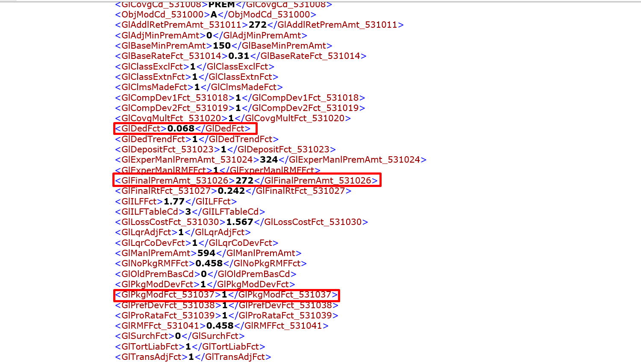

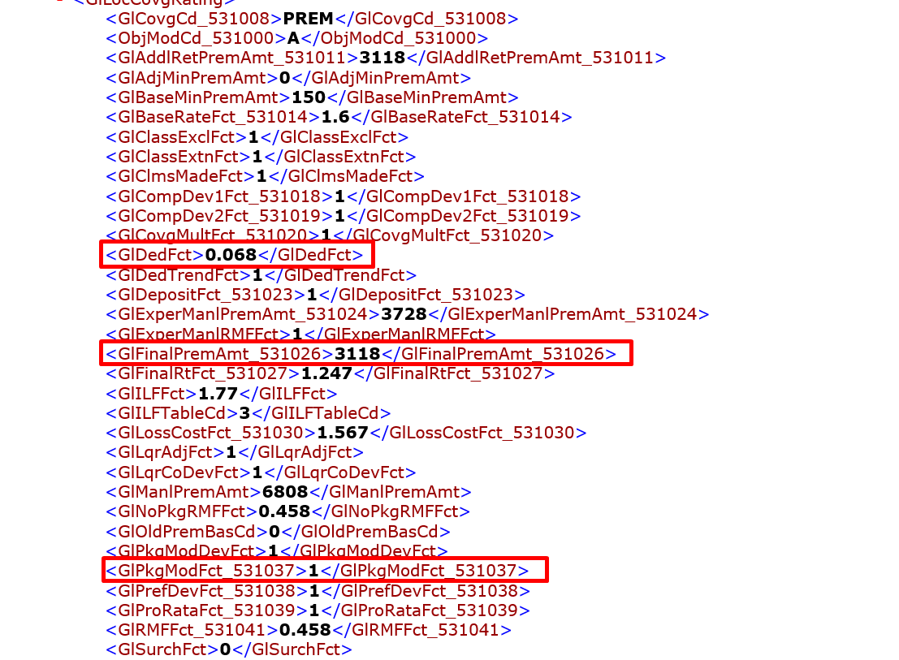
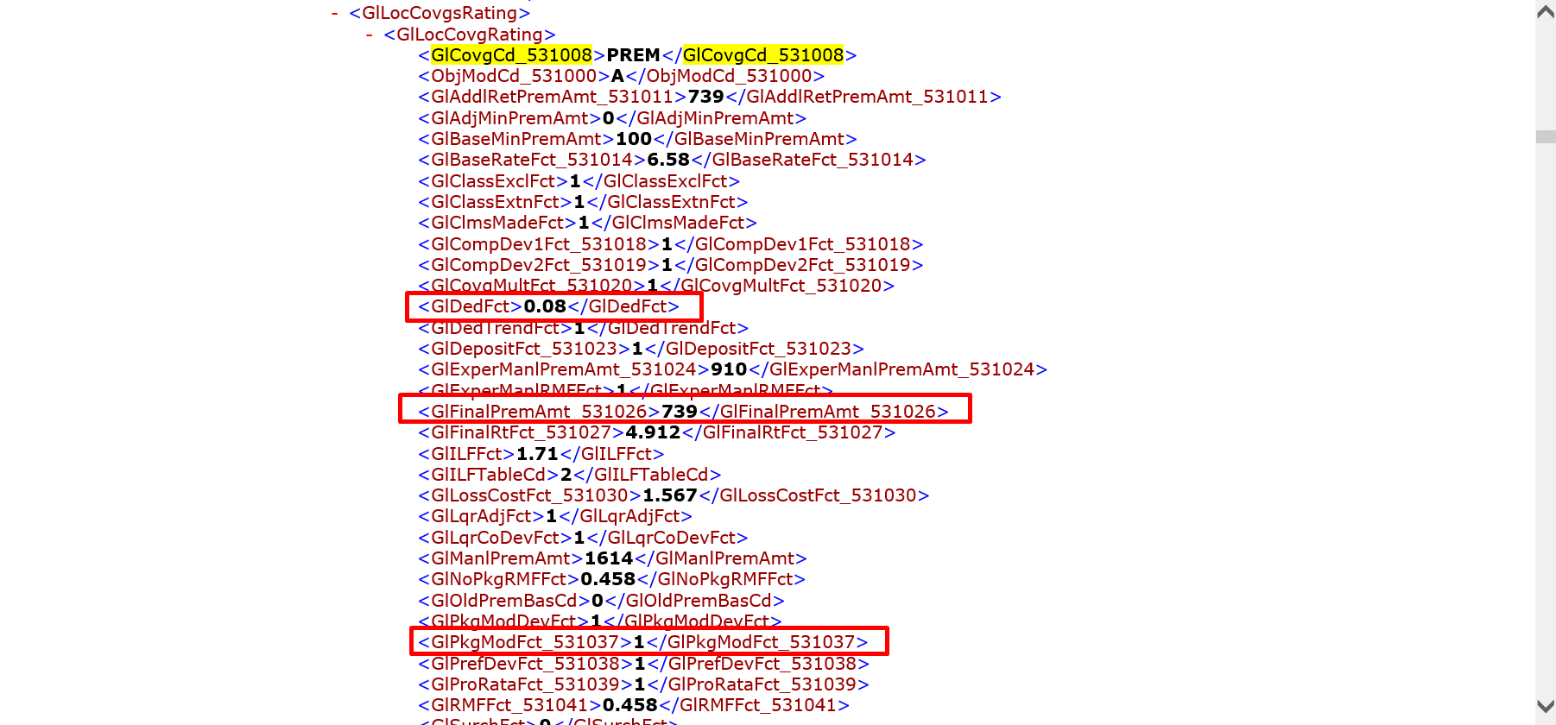

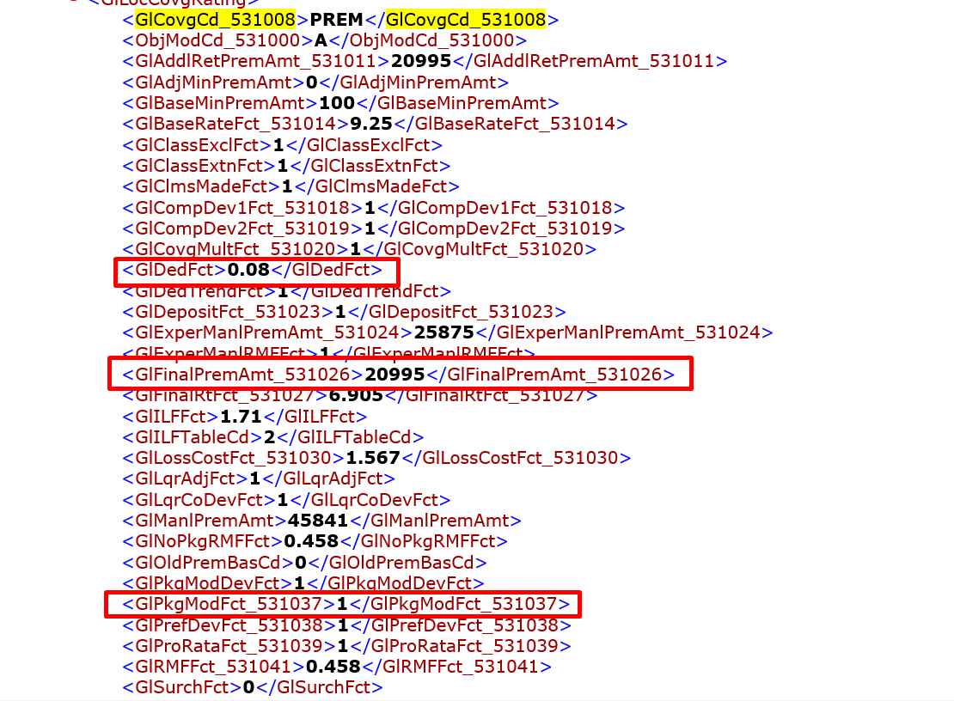

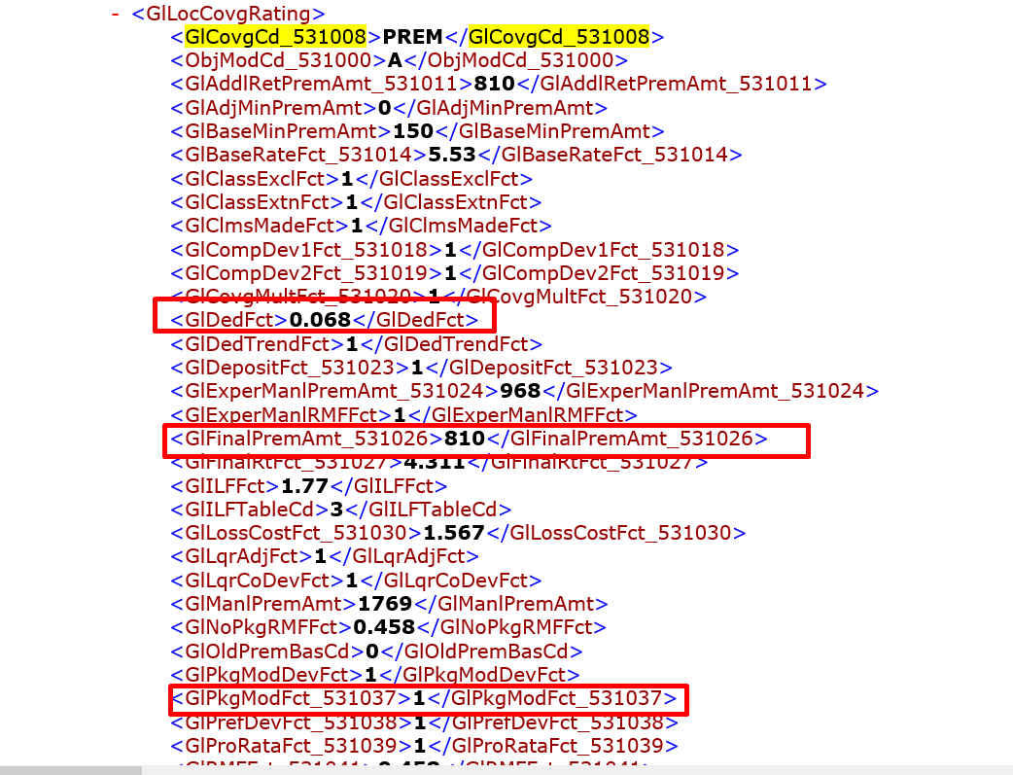

ProdCompAmtTotSI is calculated as sum of ProdCompAmtSI for each location coverage rating whose glPremDedFct is not equal to 1 .

ProdCompAmtSI = ProdCompAmtSI / (1 - glProdDedFct);
ProdCompAmtSI = ProdCompAmtSI / pkgModFctr;

ProdCompAmtSI value is taken from “GlFinalPremAmt_531026” tag from z-spire response in case of rated quote
glPremDedFct value is taken from “GlDedFct” tag from z-spire response in case of rated quote
pkgModFctr value is taken from “GlPkgModFct_531037” tag from z-spire response in case of rated quote

Sample calculations of ProdCompAmtSI for each location coverage rating are mentioned below :
ProdCompAmtSI values are 380,2953,380,23381,379
glPremDedFct values are 0.038,0.038,0.06,0.06,0.06
pkgModFctr values are 1,1,1,1,1

ProdCompAmtSI = 380/ (1 -0.038)= 395.01039501039501039501039501;
ProdCompAmtSI = 395.01039501039501039501039501/1= 395.01039501039501039501039501;
ProdCompAmtSI = 2953/ (1 -0.038)= 3069.6465696465696465696465696;
ProdCompAmtSI = 3069.6465696465696465696465696 /1= 3069.6465696465696465696465696;

ProdCompAmtSI = 380/ (1 -0.06)= 404.25531914893617021276595745;
ProdCompAmtSI = 404.25531914893617021276595745/1= 404.25531914893617021276595745;

ProdCompAmtSI = 23381/ (1 -0.038)= 24873.404255319148936170212766;
ProdCompAmtSI = 24873.404255319148936170212766/1= 24873.404255319148936170212766;

ProdCompAmtSI = 379/ (1 -0.038)= 403.19148936170212765957446809;
ProdCompAmtSI = 403.19148936170212765957446809/1=403.19148936170212765957446809;

ProdCompAmtTotSI = 395.01039501039501039501039501 + 3069.6465696465696465696465696 + 404.25531914893617021276595745 + 24873.404255319148936170212766 + 403.19148936170212765957446809

ProdCompAmtTotSI = 29,145.50802

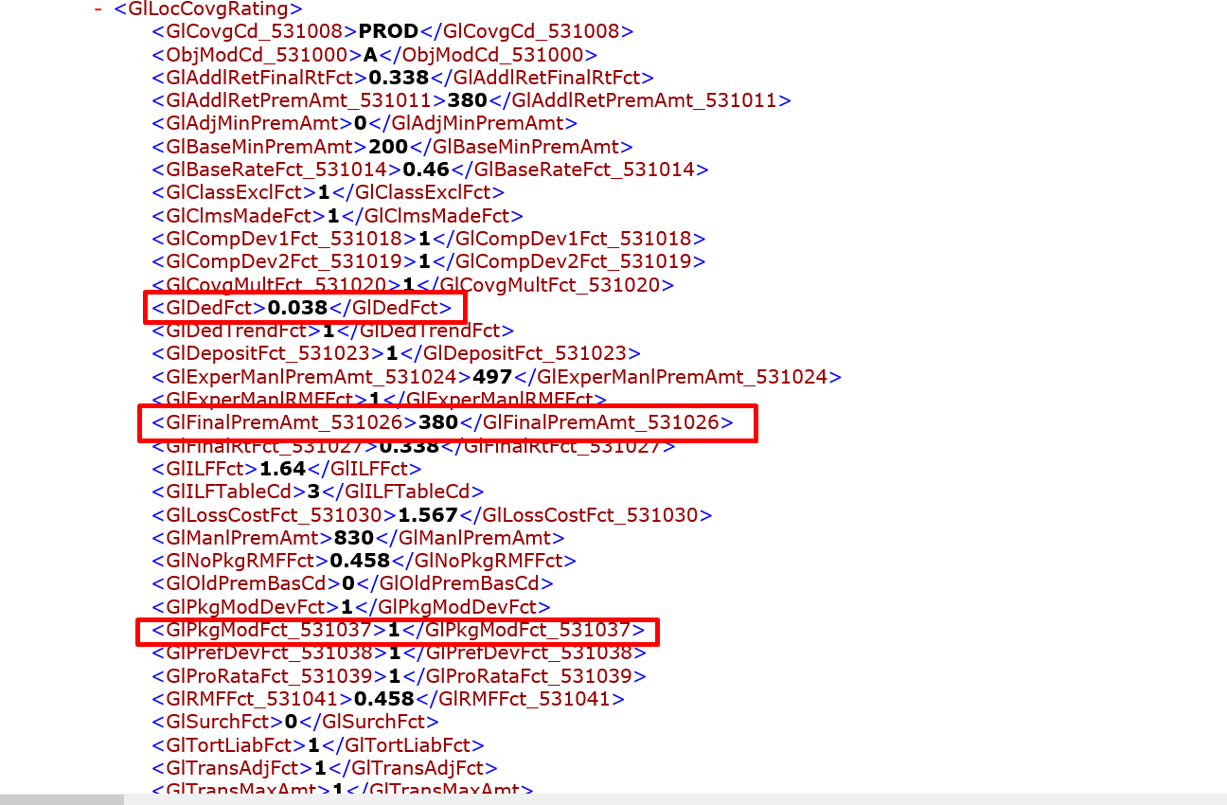

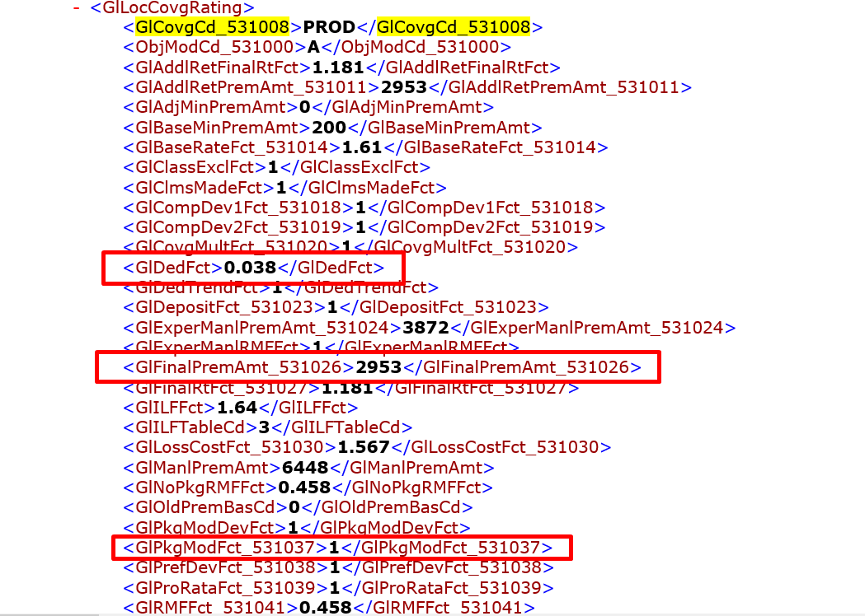

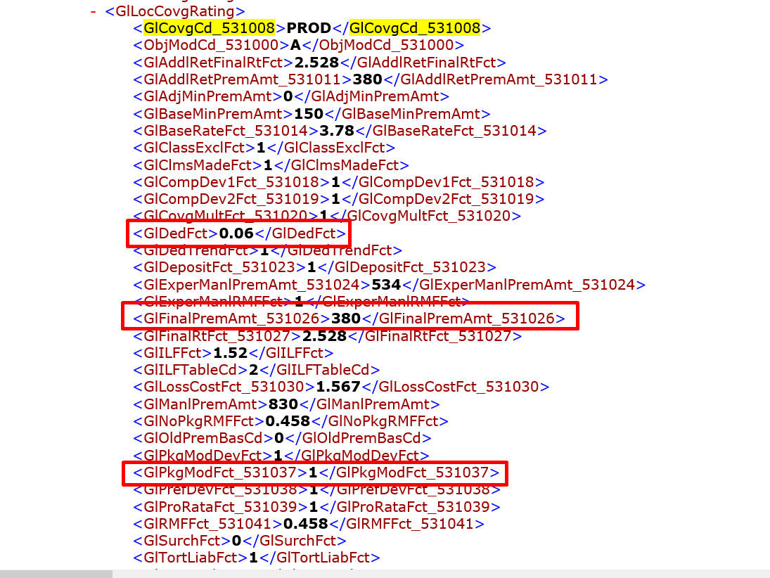

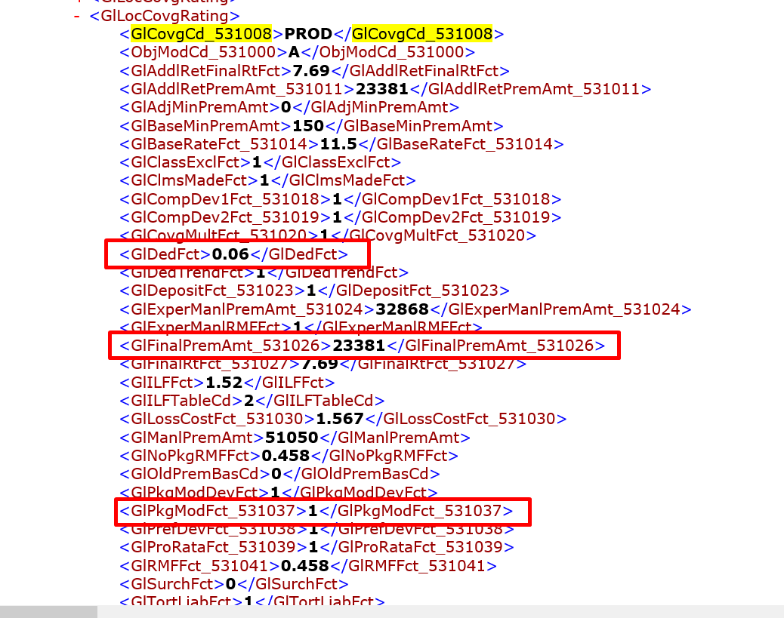
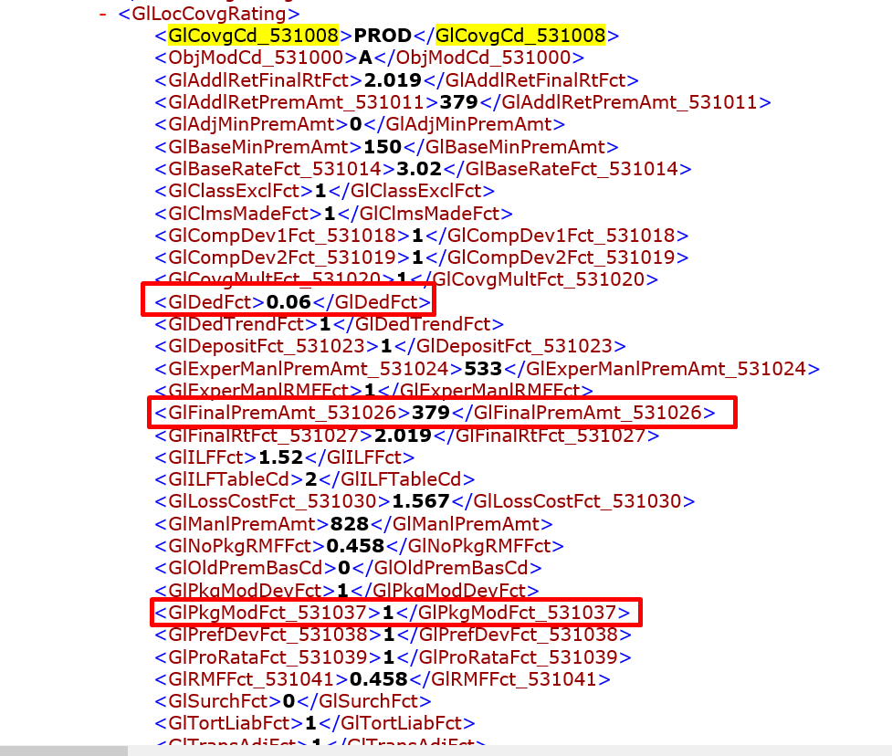

dToCovgAmndPremiumSI is calculated as
dToCovgAmndPremiumSI = dTotalExclPremSI + dTotalExtnPremSI + dTotalClsExclPremSI + dTotalClsExtnPremSI +((dTotalStOptionalPrem + dTotalPolOptionalPrem + dTotalClsOptionalPrem + dStateLvlStopGapPrem) * glProRataFactor);
dTotalExclPremSI Calculation:
For the calculation of dTotalExclPremSI rad checks for “ GlExclCnt” tag in z-spire response under CoPolicy/CoLobs/CoLob/GlPolInput and extracts respective Gl exclusion code from “GlExclCd” tag from z-spire response. dTotalExclPremSI value is only calculated if GlExclCnt value is equal to 1 otherwise dTotalExclPremSI value is equal to zero.

Based on GlExclCd the calculation of dTotalExclPremSI varies . The calculations are mentioned below:

Case 1 : If Gl exclusion code is not equal to “0000010” then dTotalExclPremSI is calculated as
dTotPremAmtSI= (PremOpsAmtSI * glPremIlfFct * dGlExclFct) - (PremOpsAmtSI * glPremIlfFct);
glPremIlfFct value will be feched from “GlILFFct” tag value from z-spire response if tag is not present this value will be equal to 1
dGlExclFct value will be fetched from “GlExclFct” tag value from z-spire response if tag is not present then this value will be equal to 1
PremOpsAmtSI is the value which is calculated in the above step
dTotalExclPremSI = sum of dTotPremAmtSI for each location under each state

Case 2 : If Gl exclusion code is not equal to “0000100” then dTotalExclPremSI is calculated as

dTotPremAmtSI += (ProdCompAmtSI * glProdIlfFct * dGlExclFct) - (ProdCompAmtSI * glProdIlfFct);

glProdIlfFct value will be feched from “GlILFFct” tag value from z-spire response if tag is not present this value will be equal to 1
dGlExclFct value will be fetched from “GlExclFct” tag value from z-spire response if tag is not present then this value will be equal to 1
ProdCompAmtSI is the value which is calculated in the above step
dTotalExclPremSI = sum of dTotPremAmtSI for each location under each state

dTotalExtnPremSI Calculation :
For the calculation of dTotalExtnPremSI rad checks for “GlExtnCnt” tag in z-spire response under CoPolicy/CoLobs/CoLob/GlPolInput and extracts respective Gl extension code from “GlExtnCd” tag from z-spire response. dTotalExtnPremSI value is only calculated if GlExtnCd value is equal to 1 otherwise dTotalExtnPremSI value is equal to zero.

Case 1 : If Gl extension code is not equal to “ 1” then dTotalExtnPremSI is calculated as
dTotPremAmtSI = (PremOpsAmtSI * glPremIlfFct * dGlExtnFct) - (PremOpsAmtSI * glPremIlfFct);
glPremIlfFct value will be feched from “GlILFFct” tag value from z-spire response if tag is not present this value will be equal to 1
dGlExclFct value will be fetched from “GlExclFct” tag value from z-spire response if tag is not present then this value will be equal to 1
PremOpsAmtSI is the value which is calculated in the above step
dTotalExtnPremSI = sum of dTotPremAmtSI for each location under each state

Case 2 : If Gl exclusion code is not equal to “ 1” then dTotalExtnPremSI is calculated as

dTotPremAmtSI += (ProdCompAmtSI * glProdIlfFct * dGlExtnFct) - (ProdCompAmtSI * glProdIlfFct);
glProdIlfFct value will be feched from “GlILFFct” tag value from z-spire response if tag is not present this value will be equal to 1
dGlExclFct value will be fetched from “GlExclFct” tag value from z-spire response if tag is not present then this value will be equal to 1
ProdCompAmtSI is the value which is calculated in the above step
dTotalExtnPremSI = sum of dTotPremAmtSI for each location under each state

dTotalClsExclPremSI Calclation:
For calculation of dTotalClsExclPremSI rad checks for “GlExclCnt_525025” , “GlExclCd_525024” tag values for each location under each state if both tag values are present then dTotalClsExclPremSI value will be calculated otherwise this value is equal to zero.
dTotPremAmtSI = (PremOpsAmtSI * glPremIlfFct * dClsExclFct) - (PremOpsAmtSI * glPremIlfFct);
PremOpsAmtSI is the value which is calculated in the above step
dClsExclFct value will be fetched from “GlExclFct_525026” tag value from z-spire response .
glPremIlfFct value will be fetched from “GlILFFct” tag value from z-spire response if tag is not present this value will be equal to 1

dTotalClsExclPremSI = sum of dTotPremAmtSI values for each location under each state

dTotalClsExtnPremSI Calculation :

For calculation of dTotalClsExtnPremSI rad checks for “GlExtnFct_525029” tag value for each location under each state if tag value is present then dTotalClsExtnPremSI value will be calculated otherwise this value is equal to zero.

dTotPremAmtSI = (PremOpsAmtSI * glPremIlfFct * dClsExtnfct) - (PremOpsAmtSI * glPremIlfFct);

dClsExtnfct value will be fetched from “GlExtnFct_525029” tag value from z-spire response .

PremOpsAmtSI is the value which is calculated in the above step
glPremIlfFct value will be fetched from “GlILFFct” tag value from z-spire response if tag is not present this value will be equal to 1

dTotalClsExtnPremSI = sum of dTotPremAmtSI values for each location under each state

dTotalPolOptionalPrem Calculation :

Rad fetches all the policy ratings under “GlPolSplitInfos/GlPolSplitInfo/GlPolRating/GlPolPremTotsRating/GlPolPremTotRating” from z-spire response and then fetches coverage code for each policy rating from “GlCovgCd_510003” tag and checks whether this coverage code is present in rad GL coverage code lookup table , if that coverage code is present in that table next rad fetches premium amount for this coverage code from “GlTotPremAmt” tag from z-spire response.

dTotalPolOptionalPrem value is equal to sum of premiums whose coverage code’s are equal to AIM1, AIM2, AIM3, AIM4, AIM5, AIO1, AIO2, AIO3, AIO4, AIO5, HOME, ZAFG, LIQR and rest other premiums are ignored

Next rad fetches all policy optional premiums under “GlPolSplitInfos/GlPolSplitInfo/GlPolCovgsInput/GlPolCovgInput” from z-spire and then fetches coverage codes from “GlCovgCd” tag for each premium and checks whether this coverage code is present in rad GL coverage code lookup table , if present next it fetches respective coverage premium type from GL coverage code lookup table if coverage type is in PREM, CHARGE, and coverage code should not be in ADD1,ADD2,ADD3,ADD4,ADD5 then it fetches premium amount from “GlPremAmt” tag and add these values to dTotalPolOptionalPrem .

Next rad fetches state level coverage ratings from “GlPolSplitInfos/GlPolSplitInfo/GlPolSplitInput/GlStInputs/GlStInput/GlStRating/GlStCovgsRating/GlStCovgRating” from z-spire response and fetches respective coverage codes from “GlCovgCd_517004” tag and check whether this coverage code is equal to “ZDEB” if it is equal then it fetches respective premium amount from “GlFinalPremAmt” tag from z-spire and add this value to dTotalPolOptionalPrem

Let us consider below example in this case

dTotalPolOptionalPrem=1037 + 1099+154=2290

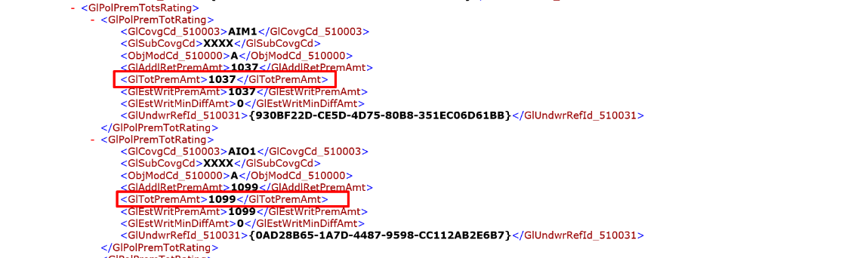

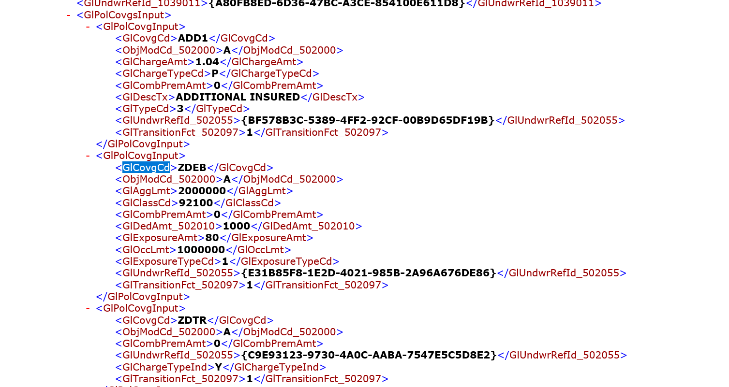

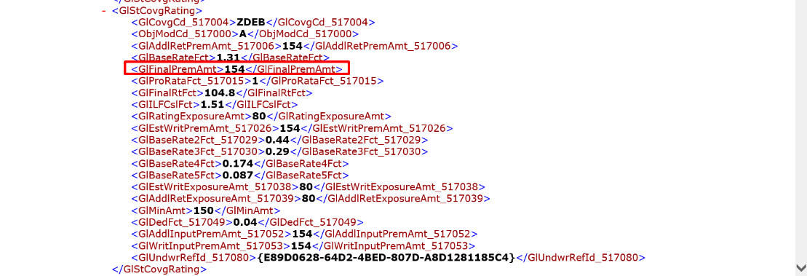
dTotalStOptionalPrem Calculation:

Rad fetches all the policy ratings under “GlPolSplitInfos/GlPolSplitInfo/GlPolRating/GlPolPremTotsRating/GlPolPremTotRating” from z-spire response and then fetches coverage code for each policy rating from “GlCovgCd_510003” tag and checks whether this coverage code is present in rad GL coverage code lookup table , if that coverage code is present in that table next rad fetches premium amount for this coverage code from “GlTotPremAmt” tag from z-spire response.

dTotalPolOptionalPrem value is equal to sum of premiums whose coverage code’s are equal to HOME, ZAFG, LIQR.

dTotalClsOptionalPrem Calculations:

Rad checks for “GlCovgCd_528008” tag under “GlLocCovgsInput/GlLocCovgInput” in z-spire response if present then it will calculate the value otherwise this value is equal to zero.

Rad fetches coverage code for each location coverage from “GlCovgCd_528008” tag and checks whether coverage code is present in rad GL coverage code lookup table and coverage type is equal to “CHARGEAMT” if this condition is satisfied then it fetches respective charge amount from “GlChargeAmt_528010” tag from z-spire . dTotalClsOptionalPrem value is equal to sum of all the charge amount’s .

dStateLvlStopGapPrem Calculations:

Rad fetches all the state level information under “GlPolSplitInfos/GlPolSplitInfo/GlPolSplitInput/GlStInputs/GlStInput” from z-spire response and checks whether state name is present in any one of these states “ND*OH*WA*WY”. If this condition satisfied next it fetches sate level coverage rating information and checks whether the coverage code is equal to “ZDSG” if it is equal then it fetches respective rmf factor , premium amount ,proratafactor .

dStateLvlStopGapPremIntial = Premium amount / rmf factor

dStateLvlStopGapPrem = dStateLvlStopGapPremIntial/ proratafactor

In other cases dStateLvlStopGapPrem is equal to zero

dToCovgAmndPremiumSI = dTotalExclPremSI + dTotalExtnPremSI + dTotalClsExclPremSI + dTotalClsExtnPremSI +((dTotalStOptionalPrem + dTotalPolOptionalPrem + dTotalClsOptionalPrem + dStateLvlStopGapPrem) * glProRataFactor);
dToCovgAmndPremiumSI = 0 + 0 + 0 + 0 +((0+2290+0+0)*1)=2290

GL manual premium = PremOpsAmtTotSI + ProdCompAmtTotSI + dToCovgAmndPremiumSI
= 28,130.35081 + 29,145.50802 + 2290
= 59,565.85883

